Please write clearly, in BLOCK CAPITALS and black ink

Centre number Candidate number

Forename(s)

Surname

Date of Exam Time allowed: 2 hours

GCSE Computer Science

Paper 1: Computational thinking and programming skills

Total Marks

PAPER 1B

Instructions

* Write in black ink or black ball-point pen. Use pencil only for drawing.
* Write your answer to each question in the space provided
* Answer all questions
* Do all rough work in this book
* Cross through any work you do not want marked
* **Questions that require a coded solution must be answered in Python 3**
* **You are not allowed to use a calculator**

Information

* The total mark for this paper is **90**
* The student version of this paper has **23** pages

**Advice**

* For multiple-choice questions, completely fill in the lozenge next to the answer you want to select.



* Icon

  Description automatically generatedTo change your answer, cross out your original answer like this: Icon

  Description automatically generated
* If you want to go back to an answer you previously crossed out, circle the answer you now want to select like this:

**Answer ALL questions.**

|  |  |  |  |
| --- | --- | --- | --- |
| **0** | **1** | **.** | **1** |

Define the term abstraction.

[2 marks]

|  |  |  |  |
| --- | --- | --- | --- |
| **0** | **2** |  |  |

The pseudo-code in **Figure 1** assigns values to variables.

**Figure 1**

start ← 5  
mult ← start * start  
mult ← start * mult

|  |  |  |  |
| --- | --- | --- | --- |
| **0** | **2** | **.** | **1** |

Shade **one** lozenge that shows the value stored in the variable start once the program in **Figure 1** has finished running.

[1 mark]

|  |  |  |
| --- | --- | --- |
| **A** | 5 |  |
| **B** | 10 |  |
| **C** | 25 |  |
| **D** | 15 |  |

|  |  |  |  |
| --- | --- | --- | --- |
| **0** | **2** | **.** | **2** |

Shade **one** lozenge that shows the data type for the variable mult in **Figure 1**.

[1 mark]

|  |  |  |
| --- | --- | --- |
| **A** | Boolean |  |
| **B** | Floating point number |  |
| **C** | Integer |  |
| **D** | String |  |

|  |  |  |  |
| --- | --- | --- | --- |
| **0** | **3** |  |  |

The algorithm in **Figure 2** is used to calculate the number of car parking spaces left in a car park.

* Line numbers are included but are not part of the algorithm.

**Figure 2**

1 CONSTANT TOTAL_SPACES ← 200

2 currentSpaces ← TOTAL_SPACES

3

4 SUBROUTINE CAR_ENTERS():

5 currentSpaces ← currentSpaces – 1

6 ENDSUBROUTINE

7

8 SUBROUTINE CAR_EXITS():

9 currentSpaces ← currentSpaces + 1

10 ENDSUBROUTINE

11

12 CAR_ENTERS()

13 CAR_ENTERS()

14 CAR_EXITS()

15

16 IF currentSpaces < 1 THEN

17 OUTPUT "Car park full"

18 ENDIF

19 OUTPUT currentSpaces

|  |  |  |  |
| --- | --- | --- | --- |
| **0** | **3** | **.** | **1** |

Shade **one** lozenge which explains the meaning of the relational operator < in line 16 in **Figure 2**.

[1 mark]

|  |  |  |
| --- | --- | --- |
| **A** | Greater than |  |
| **B** | Greater than or equal to |  |
| **C** | Less than |  |
| **D** | Less than or equal to |  |

|  |  |  |  |
| --- | --- | --- | --- |
| **0** | **3** | **.** | **2** |

Shade **one** lozenge which shows the number of subroutines present in the program. **Figure 2**.

[1 mark]

|  |  |  |
| --- | --- | --- |
| **A** | 2 |  |
| **B** | 3 |  |
| **C** | 5 |  |
| **D** | 7 |  |

|  |  |  |  |
| --- | --- | --- | --- |
| **0** | **3** | **.** | **3** |

Shade **one** lozenge which shows the data type of the variable currentSpaces in   
**Figure 2**.

[1 mark]

|  |  |  |
| --- | --- | --- |
| **A** | Character |  |
| **B** | Integer |  |
| **C** | Real |  |
| **D** | String |  |

|  |  |  |  |
| --- | --- | --- | --- |
| **0** | **3** | **.** | **4** |

Shade **one** lozenge which gives the meaning of CONSTANT in line 1 in **Figure 2**.

[1 mark]

|  |  |  |
| --- | --- | --- |
| **A** | The value it stores is able to change while the program is running. |  |
| **B** | The value it stores is not able to change while the program is running. |  |
| **C** | It is not possible to read the value stored while the  program is running |  |
| **D** | The line of code cannot be changed from line 1. |  |

|  |  |  |  |
| --- | --- | --- | --- |
| **0** | **3** | **.** | **5** |

State the line number where selection starts in **Figure 2**.

[1 mark]

|  |  |  |  |
| --- | --- | --- | --- |
| **0** | **3** | **.** | **6** |

Shade **one** lozenge which gives the output from the program in **Figure 2**.

[1 mark]

|  |  |  |
| --- | --- | --- |
| **A** | Car park full |  |
| **B** | 198 |  |
| **C** | 199 |  |
| **D** | 201 |  |

|  |  |  |  |
| --- | --- | --- | --- |
| **0** | **4** |  |  |

A programmer has written a Python program for a hotel’s reception staff to decide whether they should have the front door open or closed.

The door should be closed when either the temperature is less than 15°C or the chance of it raining is more than 10%. Otherwise, the doors should be open. Both the temperature and the chance of rain are entered as a whole number.

Complete the program below by filling in the gaps using the items in **Figure 3**. You will not need to use all the items in **Figure 3**. Each item in **Figure 3** should only be used once.

[5 marks]

**Figure 3**

|  |  |  |  |
| --- | --- | --- | --- |
| if | elif | else: |  |
| and | not | or |  |
| bool | float | int |  |
| < | <= | > | >= |
| : | ) | then |  |

temperature = int(input("Temperature: "))

chanceOfRain = (input("Chance of rain: "))

if chanceOfRain > 10 temperature 15

print("Close doors")

print("Open doors")

|  |  |  |  |
| --- | --- | --- | --- |
| **0** | **5** |  |  |

The algorithm in **Figure 4** is a searching algorithm.

* Array indexing starts at 0.
* Line numbers are included but are not part of the algorithm.

**Figure 4**

1. arr ← [3, 5, 6, 8, 9, 11, 15, 16, 18]
2. x ← 16
3. mid ← 0
4. low ← 0
5. high ← LEN(arr) - 1
6. found ← False
7. WHILE low <= high AND NOT found:
8. mid ← (high + low) // 2
9. IF arr[mid] < x THEN
10. low ← mid + 1
11. ELSE IF arr[mid] > x:
12. high ← mid - 1
13. ELSE
14. found ← True
15. ENDIF
16. ENDWHILE
17. IF found:
18. OUTPUT mid
19. ELSE
20. OUTPUT "Not found"

|  |  |  |  |
| --- | --- | --- | --- |
| **0** | **5** | **.** | **1** |

State the value of LEN(arr).

[1 mark]

|  |  |  |  |
| --- | --- | --- | --- |
| **0** | **5** | **.** | **2** |

Shade **one** lozenge to show which of the following contains the **false** statement about the algorithm in **Figure 4**.

[1 mark]

|  |  |  |
| --- | --- | --- |
| **A** | The algorithm uses variables |  |
| **B** | The algorithm uses indefinite iteration |  |
| **C** | The algorithm uses a 2D array |  |

|  |  |  |  |
| --- | --- | --- | --- |
| **0** | **5** | **.** | **3** |

Shade **one** lozenge which gives the name of the // operator in line 10 in **Figure 2**.

[1 mark]

|  |  |  |
| --- | --- | --- |
| **A** | Assignment |  |
| **B** | Division |  |
| **C** | Integer division |  |
| **D** | Modulus |  |

|  |  |  |  |
| --- | --- | --- | --- |
| **0** | **5** | **.** | **4** |

Complete the trace table for the algorithm shown in **Figure 4** some values have already been entered. You do not have to use all rows.

[5 marks]

|  |  |  |  |  |
| --- | --- | --- | --- | --- |
| **mid** | **low** | **high** | **found** | **OUTPUT** |
| 0 | 0 |  |  |  |
|  |  |  |  |  |
|  |  |  |  |  |
|  |  |  |  |  |
|  |  |  |  |  |
|  |  |  |  |  |
|  |  |  |  |  |
|  |  |  |  |  |

|  |  |  |  |
| --- | --- | --- | --- |
| **0** | **5** | **.** | **5** |

State the name of the algorithm given in **Figure 4**.

[1 mark]

|  |  |  |  |
| --- | --- | --- | --- |
| **0** | **6** |  |  |

Write a Python program that calculates the area of a triangle. The formula to calculate the area is:

*area = (base × height) ÷ 2*

The program should:

* Allow the user to enter the base in metres (the user may enter floating point numbers)
* Allow the user to enter the height in metres (the user may enter floating point numbers)
* Validate that both base and height have been entered
* If either base or height have not been entered, output “You must enter numbers for both base and height"
  + The program does not need to ask the user to enter the base and height again if they don’t enter numbers for base or height
* If both base and height are entered, calculate and output the area of the triangle

You should use meaningful variable name(s), correct syntax and indentation in your answer.

The answer grid below contains vertical lines to help you indent your code accurately.

[9 marks]

|  |  |  |  |  |
| --- | --- | --- | --- | --- |
|  |  |  |  |  |
|  |  |  |  |  |
|  |  |  |  |  |
|  |  |  |  |  |
|  |  |  |  |  |
|  |  |  |  |  |
|  |  |  |  |  |
|  |  |  |  |  |
|  |  |  |  |  |
|  |  |  |  |  |
|  |  |  |  |  |
|  |  |  |  |  |
|  |  |  |  |  |
|  |  |  |  |  |
|  |  |  |  |  |
|  |  |  |  |  |
|  |  |  |  |  |
|  |  |  |  |  |
|  |  |  |  |  |
|  |  |  |  |  |
|  |  |  |  |  |
|  |  |  |  |  |
|  |  |  |  |  |
|  |  |  |  |  |
|  |  |  |  |  |
|  |  |  |  |  |
|  |  |  |  |  |
|  |  |  |  |  |
|  |  |  |  |  |
|  |  |  |  |  |
|  |  |  |  |  |
|  |  |  |  |  |
|  |  |  |  |  |
|  |  |  |  |  |

|  |  |  |  |
| --- | --- | --- | --- |
| **0** | **7** |  |  |

Write a Python program that creates usernames.

The program allows the user to input their last name. It then takes the first four letters of the name and combines it with a random number between 1 and 9. You can assume that all names entered will be four letters or longer.

For example, if the user enters “SINCLAIR”, the program outputs: SINC5 (the program randomly could output any username from SINC1 to SINC9)

Your program should work as follows:

* Gets the user to enter a string and store it in a suitable variable
* Calculate a random number between 1 and 9
* Create a username from the first four characters of the name entered and the random number
* Output the username

You should use meaningful variable name(s), correct syntax and indentation in your answer.

The answer grid below contains vertical lines to help you indent your code accurately.

[8 marks]

|  |  |  |  |  |
| --- | --- | --- | --- | --- |
|  |  |  |  |  |
|  |  |  |  |  |
|  |  |  |  |  |
|  |  |  |  |  |
|  |  |  |  |  |
|  |  |  |  |  |
|  |  |  |  |  |
|  |  |  |  |  |
|  |  |  |  |  |
|  |  |  |  |  |
|  |  |  |  |  |
|  |  |  |  |  |
|  |  |  |  |  |
|  |  |  |  |  |
|  |  |  |  |  |
|  |  |  |  |  |
|  |  |  |  |  |
|  |  |  |  |  |
|  |  |  |  |  |
|  |  |  |  |  |
|  |  |  |  |  |
|  |  |  |  |  |
|  |  |  |  |  |
|  |  |  |  |  |
|  |  |  |  |  |
|  |  |  |  |  |
|  |  |  |  |  |
|  |  |  |  |  |
|  |  |  |  |  |
|  |  |  |  |  |
|  |  |  |  |  |
|  |  |  |  |  |
|  |  |  |  |  |
|  |  |  |  |  |

|  |  |  |  |
| --- | --- | --- | --- |
| **0** | **8** |  |  |

A child’s stacking toy consists of 10 wooden blocks that can be stacked onto a pole. The blocks are labelled from smallest (1) to largest (10).

A robot has been made to stack the blocks. The following subroutines control the robot.

|  |  |
| --- | --- |
| ADD(blockNumber) | Adds the block labelled blockNumber to the top of the stack of cubes. |
| REMOVE() | Removes the top cube from the pole and returns the number of the block removed |
| HEIGHT() | Returns the number of blocks currently on the pole. |

|  |  |  |  |
| --- | --- | --- | --- |
| **0** | **8** | **.** | **1** |

The following shows how the blocks are arranged at the start.

Draw the final arrangement of the blocks after the following algorithm has run.

ADD(6)  
ADD(7)  
ADD(8)

[3 marks]

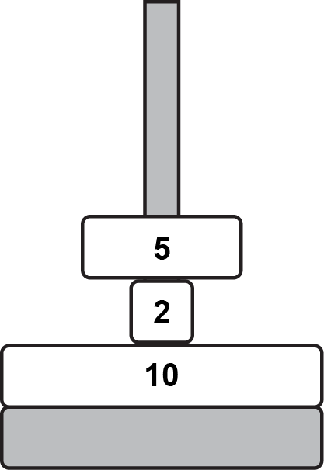

|  |  |  |  |
| --- | --- | --- | --- |
| **0** | **8** | **.** | **2** |

The pole is empty at the start.

Draw the final arrangement of the blocks on the pole after the following algorithm has run.

FOR i ← 10 TO 6 STEP -1

ADD(i)

ENDFOR

[3 marks]

|  |  |  |  |
| --- | --- | --- | --- |
| **0** | **8** | **.** | **3** |

The subroutine HEIGHT() returns the number of blocks that are currently stacked. The pole is able to hold only 7 blocks at a time.

Develop an algorithm using pseudocode for a new subroutine FULL which has no parameters and will return True if the pole is full and False if more blocks are able to be added.

[5 marks]

|  |  |  |  |
| --- | --- | --- | --- |
| **0** | **8** | **.** | **4** |

Complete the algorithm below using pseudocode which will determine if the blocks are in order with the smallest at the top and the largest at the bottom.

To be in order, any block can be on the bottom, but all blocks above must be exactly 1 smaller than the block it sits on. The following three arrangements are given as examples:

|  |  |  |  |  |
| --- | --- | --- | --- | --- |
| Outputs True This is because all blocks are in order |  | Outputs False This is because Block 7 is missing |  | Outputs False This is because Block 7 is larger than Block 6, but above it |

Your algorithm will assume that the pole is already stacked. The algorithm only needs to make use of the subroutines REMOVE and HEIGHT. When remove is called, the block is removed from the pole and the number on it is returned.

The algorithm currently removes the top block if there is one and stores the number on the block in the variable currentBlock. Complete the algorithm by:

* Using iteration to check all the other blocks in the stack are in order
* Output True or False depending on whether the blocks are in order

inOrder = True  
currentBlock = 0  
  
IF HEIGHT() > 0 THEN  
 currentBlock = REMOVE()  
ENDIF

[7 marks]

|  |  |  |  |
| --- | --- | --- | --- |
| **0** | **9** | **.** | **1** |

The following are computer science terms (labelled A-E).

**A** output  
**B** syntax error  
**C** abstraction  
**D** concatenation  
**E** string

For each of the definitions in the table, write the label of the most suitable Computer Science term. Use a label only once.

[3 marks]

|  |  |
| --- | --- |
|  | **Label** |
| Combining two strings together |  |
| A series of characters |  |
| Ignoring or removing unnecessary details from a problem |  |

|  |  |  |  |
| --- | --- | --- | --- |
| **0** | **9** | **.** | **2** |

An algorithm will determine if a number is between 0 and 100 inclusive. If the number input is between 0 and 100, the algorithm will output the number. Otherwise, the algorithm will output “Invalid number”.

Complete the flowchart below for the algorithm described.

[5 marks]

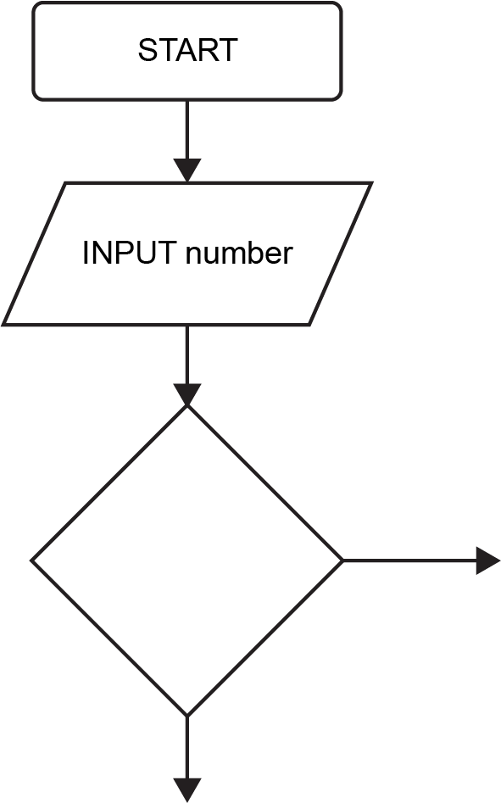

|  |  |  |  |
| --- | --- | --- | --- |
| **1** | **0** |  |  |

Fill in the blank arrays to show the steps involved in applying the bubble sort algorithm to the array ["Sam", "Dan", "Ivy", "Ed", "Eva"].

[5 marks]

|  |  |  |  |  |
| --- | --- | --- | --- | --- |
| "Sam" | "Dan" | "Ivy" | "Ed" | "Eva" |
|  |  |  |  |  |
|  |  |  |  |  |
|  |  |  |  |  |
|  |  |  |  |  |
|  |  |  |  |  |
|  |  |  |  |  |
|  |  |  |  |  |
|  |  |  |  |  |
|  |  |  |  |  |
|  |  |  |  |  |
|  |  |  |  |  |
| "Dan" | "Ed" | "Eva" | "Ivy" | "Sam" |
|  |  |  |  |  |

|  |  |  |  |
| --- | --- | --- | --- |
| **1** | **1** |  |  |

The following Python program asks the user to enter the quantity of a product they would like to buy in an online shop’s promotion. The customer will only be allowed to order between 1 and 10 of the product. The program is shown in **Figure 5**.

**Figure 5**

MAX_PRODUCTS = 10

quantity = 0

addProducts = int(input("Quantity: "))

if addProducts >= 1 and addProducts <= 10:

quantity = addProducts

print(quantity, "products added")

else:

print("You can only order up to 10 items")

|  |  |  |  |
| --- | --- | --- | --- |
| **1** | **1** | **.** | **1** |

The test data in the following test plan is for three different types of test.  
Complete the test plan for the code shown in **Figure 5**.

[2 marks]

|  |  |  |
| --- | --- | --- |
| **Test type** | **Test data** | **Expected result** |
| Normal data | 6 | Output “6 products added” |
|  | -5 |  |
|  | 11 |  |

|  |  |  |  |
| --- | --- | --- | --- |
| **1** | **1** | **.** | **2** |

The program currently only asks the user to enter the quantity once.

Using Python only, change the program code in **Figure 5** so that if the user enters an invalid number (outside the range 0 to 10), the program will explain that an invalid number has been entered and ask them to enter the quantity. The program will repeatedly do this until a valid number has been entered.

**Figure 5**

MAX_PRODUCTS = 10

quantity = 0

addProducts = int(input("Quantity: "))

if addProducts >= 1 and addProducts <= 10:

quantity = addProducts

else:

print("You can only order up to 10 items")

print(quantity, "products added")

[4 marks]

|  |  |  |  |
| --- | --- | --- | --- |
| **1** | **2** |  |  |

A Python program has been written to calculate the number of 500 gram bags required to store an amount of flour entered by the user. The program also calculates the amount of left-over flour once all the bags have been filled. The program is shown in **Figure 6**.

**Figure 6**

BAG_SIZE = 500

flourWeight = int(input("How much flour delivered: "))

bagsNeeded = flourWeight // 500

flourLeft = flourWeight % 500

print(bagsNeeded, "bags required")

print(flourLeft, "g of flour left over")

|  |  |  |  |
| --- | --- | --- | --- |
| **1** | **2** | **.** | **1** |

Explain why the data type of flourLeft will be an integer.

[2 marks]

|  |  |  |  |
| --- | --- | --- | --- |
| **1** | **2** | **.** | **2** |

State the output from the program when the user enters 2100 into the program.

[2 mark]

|  |  |  |  |
| --- | --- | --- | --- |
| **1** | **2** |  | **3** |

State the name of the % operator used in the line of code:

flourLeft = flourWeight % 500

[1 mark]

|  |  |  |  |
| --- | --- | --- | --- |
| **1** | **3** |  |  |

A palindrome is a word or number that reads the same backwards as it does forwards.

For example:   
racecar  
is a palindrome as it reads the same if you reverse it.

hello  
is not a palindrome as when reversed, it reads olleh.

The program should:

* Ask the user to enter a word or number
* Calculate whether the word or number is a palindrome
* If the word or number is a palindrome, output “word is a palindrome”
* If the word or number is not a palindrome, output “word is not a palindrome”

You should use meaningful variable name(s), correct syntax and indentation in your answer.

The answer grid below contains vertical lines to help you indent your code accurately.

[7 marks]

|  |  |  |  |  |
| --- | --- | --- | --- | --- |
|  |  |  |  |  |
|  |  |  |  |  |
|  |  |  |  |  |
|  |  |  |  |  |
|  |  |  |  |  |
|  |  |  |  |  |
|  |  |  |  |  |
|  |  |  |  |  |
|  |  |  |  |  |
|  |  |  |  |  |
|  |  |  |  |  |
|  |  |  |  |  |
|  |  |  |  |  |
|  |  |  |  |  |
|  |  |  |  |  |
|  |  |  |  |  |
|  |  |  |  |  |
|  |  |  |  |  |
|  |  |  |  |  |
|  |  |  |  |  |
|  |  |  |  |  |
|  |  |  |  |  |
|  |  |  |  |  |
|  |  |  |  |  |
|  |  |  |  |  |
|  |  |  |  |  |
|  |  |  |  |  |
|  |  |  |  |  |
|  |  |  |  |  |
|  |  |  |  |  |
|  |  |  |  |  |
|  |  |  |  |  |
|  |  |  |  |  |
|  |  |  |  |  |